6.42: The initial and final kinetic energies of the brick are both zero, so the net work done on the brick by the spring and gravity is zero, so 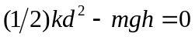, or The spring will provide an upward force while the spring and the brick are in contact. When this force goes to zero, the spring is at its uncompressed length.

